**Joint Minnesota Area 35 & Area 36 Statewide Corrections Committee**

**CORRECTIONS WORKSHOP**

October 25, 2025 (9:30 AM to 3:30 PM)

Jack & Jim’s Event Center, 11025 Duelm Road NE, Foley, MN 56329

(15 miles Northeast of St Cloud, MN)

**IN PERSON AND ONLINE!**

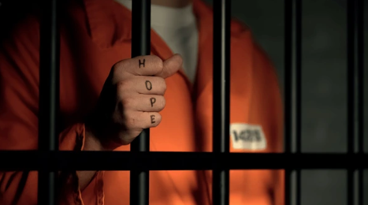

**Commissioner Paul Schnell, Minnesota Department of Corrections**

**AA Insider #1, My AA Group - Somewhere, MN**

**AA Insider #2, My AA Group - Somewhere, MN**

**Question & Answer Session**

(Step to the Mic, raise your hand online, ask our Guests anything about today’s topics!)

**Online Registration**

Go to: [2024 SWCC Corrections Workshop registration](https://events.teams.microsoft.com/event/dc097fe5-c746-4af9-82d7-a50007a9da5b@c9589300-d348-46b9-9e64-e5fec693cbfa) (Press CTRL plus CLICK to follow the Link)

for workshop information/registration or use the QR Code below. Once registered,

you will be provided with a meeting link for access the day of the event.

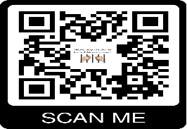

**Sandwich, Soup, and Salad Buffet Lunch for only $18.00 - FREE Coffee ALL DAY!**

**We need a head count for lunch, please RSVP using the following Link or QR Code!**

**For more information, please contact:**

Carter L [correctionsmn@gmail.com](mailto:correctionsmn@gmail.com) / David A. [corrections@area36.org](mailto:corrections@area36.org) / Mark R. [corrections@area35.org](mailto:corrections@area35.org)